**Team Charter**

**Date: 13th Mar. 2021**

1. **Team goal**

The goal of the team is to complete the client's commissioned development tasks with high quality: develop and implement a machine learning algorithm with python, which accepts inputs of the video sources provided by the client and classifies the videos according to the given label list. At the same time, the team must make the delivery of the project meet the high score standards required by the ANU Tech launcher course.

1. **Contacts and team roles**

|  |  |  |
| --- | --- | --- |
| Name | Email | Role |
| Jiawei Fan | u5922620@anu.edu.au | Spokesman, developer, quality control, meeting minutes writer |
| Yuchen Wang | u6928271@anu.edu.au | Spokesman, developer, editor, harmonizer |
| Yuliang Ma | u6462980@anu.edu.au | Developer, planner, reflection writer, human Conscience |
| Xiaoxiang Kong | u6828507@anu.edu.au | Developer, checker, editor |
| Yimin Xu | u6534123@anu.edu.au | Developer, checker, editor |

1. **Grounds rules**
2. Open views, respect each other, and participation is the most important.
3. Decision-making is based on the principle of minority obedience to majority.
4. The team members will receive a warning from the team if they miss the delivery without reason for the first time and will report it to tutors the second time. This should so up in the audit contribution reports.
5. **Meeting regulations**

The meeting system is the key to ensuring the smooth operation of the team and the quality of deliverables. The team’s meetings will be held at regular intervals, including internal meetings, customer meetings and tutorial consultation meetings. The discussion topics and agenda of the meeting are as follows:

* 1. **Internal meetings**

Internal meetings are meetings where only team members participate, and all team members should be involved.

The time and frequency of the meeting is two or three times per week. The exact time of the meeting can be discussed through WeChat to ensure that at the meeting time every member is available.

There are two types of internal meetings:

1. Task progress synchronization and planning for future work

This meeting’s function is to check work progress based on the tasks assigned to each member. Then we can discuss about future plans.

1. Reflection meetings

This meeting’s function is to reflect our work for last week based on the tutors’ and peers’ feedback.

* 1. **Client meetings**

The client meetings are meetings between the team members and the client to communicate on project issues. It is scheduled to be held once a week, and the specific date is specified by the client.

Given that the team members are in different countries and time zones, the team will send 2-3 representatives to talk with the client in each meeting. The format is online via Zoom. After the meeting, we will upload the meeting minutes to the repository so that other members can go through the meeting minutes, and get an understanding of the meetings.

Topics discussed at client meets include reporting the latest project progress to the client, listening to the client's latest opinions on project development, and reaching consensus with the client on key issues such as development resources and schedules.

* 1. **Tutorial consultation meetings**

Tutorial consultation meetings are regular meetings called by the organizers of the COMP8715 course to monitor the progress and quality of the project.

This meeting is scheduled to be held every Wednesday from 8 am to 10 am through the Zoom online meeting. Every team member is required to participate. If a member is absent without a reason, we may consider to lower the contribution of this team member.

At the meeting, the team report the progress of the project to the tutors, put forward some difficulties and challenges related to the project, and obtained tutors’ suggestions and help.

1. **Decision making process**

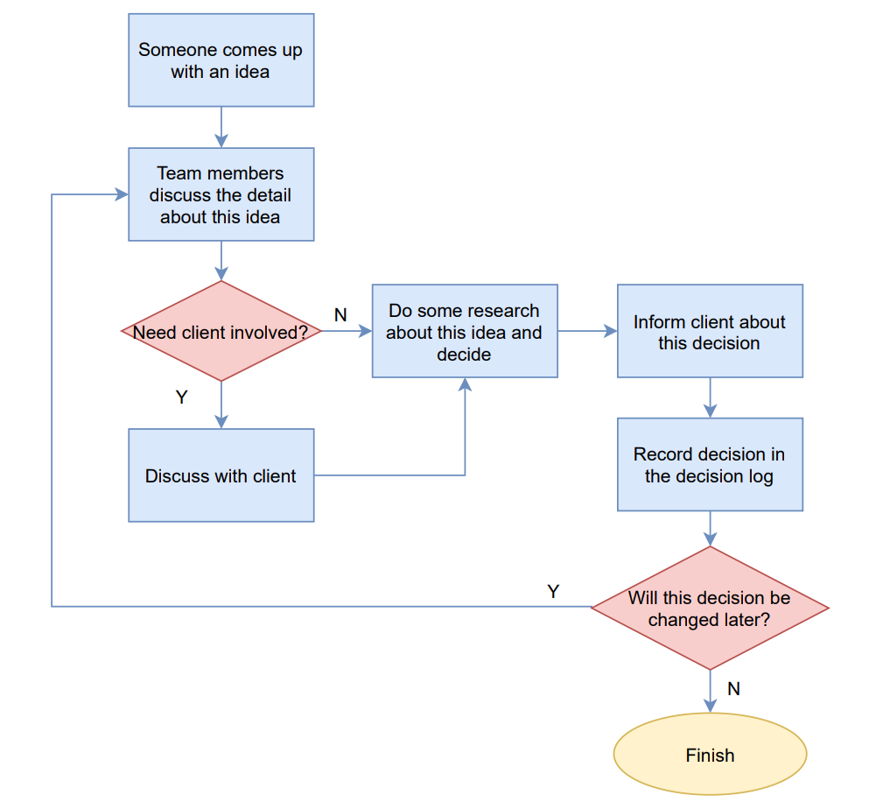

1. **Communication norms**
   1. **Internal communication**

Since the members of this team are in different countries and time zones, the internal communication adopts a mixture of multiple communication methods.

The main daily communication method within the team is WeChat text messages and Zoom online meetings. The reply time for a message should not exceed 2 hours. For the communication of urgent matters, our team uses WeChat online calls.

For the three students in Australia, if necessary, they will work in the form of face-to-face and offline workshops.

All sessions and work records will be saved in the team repo.

* 1. **Communication with the client**

1. Face to face

If the client stays in Canberra and he is able to meet us face to face, then we can hold a face-to-face meeting with him which may be more efficient than online meeting.

1. Zoom

If the client is too busy to meet us in person or he is not in Canberra, then we can hold a online meeting via zoom.

1. Telephone

If we are not able to get in touch with the client, we may need to dial his phone number.